**LAB ASSIGNMENT #6**

**STATEMENT:** WRITE A PROGRAM TO IMPLEMENT “LIBRARY MANAGEMENT SYSTEM” USING FUNCTION, STRUCTURE AND POINTER. INCLUDE:

1. INSERT -> ADD NEW BOOKS
2. DELETE -> REMOVE BOOKS
3. DISPLAY -> DISPLAY RECORDS
4. UPDATE

**SOURCE CODE:**

#include <stdio.h>

#include <conio.h>

#include <string.h>

#include <stdlib.h>

typedef struct{

int id;

char name[20];

int athr;

}rec;

rec user, *ptr=&user, *temp;

int nor=0, i;

void add()

{

int n;

printf("\n How many records do you want to add?");

scanf("%d", &n);

for(i=0;i<n;i++)

{

printf("\n Enter the information");

printf("\n ID: ");

scanf("%d",&(ptr+i)->id);

fflush(stdin);

printf("\n Name ofbook ; ");

scanf("%s",(ptr+i)->name);

fflush(stdin);

printf("\n Author: ");

scanf("%d",&(ptr+i)->athr);

nor++;

}

}

void del()

{

int did, i, alt;

printf("\n Enter id to delete");

scanf("%d",&did);

for(i=0, alt=0;i<nor;i++, alt++)

{

if((ptr+alt)->id==did)

{

alt--; nor--;

printf("Record deleted");

}

else

{

(ptr+alt)->id=(ptr+i)->id;

strcpy((ptr+alt)->name,(ptr+i)->name);

(ptr+alt)->id=(ptr+i)->athr;

}

}

}

void update()

{

int upd, i;

printf("\n Enter id to update");

scanf("%d",&upd);

for(i=0;i<nor;i++)

{

if((ptr+i)->id==upd)

{

printf("\n Enter the information");

printf("\n ID: ");

scanf("%d",&(ptr+i)->id);

fflush(stdin);

printf("\n Name; ");

scanf("%s",(ptr+i)->name);

fflush(stdin);

printf("\n Author: ");

scanf("%d",&(ptr+i)->athr);

printf("\nRecord updated");

}

}

}

void display()

{

int dis;

printf("\n %d,%s,%s", (ptr+i)->id,(ptr+i)->name,(ptr+i)->athr);

fflush(stdin);

}

void main(void)

{

clrscr();

int choice;

while(1)

{

printf("\t Menu:\ti) Add books\tii) Delete\tiii) Update\tiv)display \t v) Exit");

printf("\n Enter your choice");

scanf("%d",&choice);

switch(choice)

{

case 1:

{

add();

break;

}

case 2:

{

del();

break;

}

case 3:

{

update();

break;

}

case 4:

{

display();

break;

}

case 5:

{

printf("\n please, press any key to end . . .");

getch();

exit(1);

}

default:

{

printf("\n ERROR!!. Press any key and please try again");

getch();

}

}

}

}

**OUTPUT:**

1. **Add:**

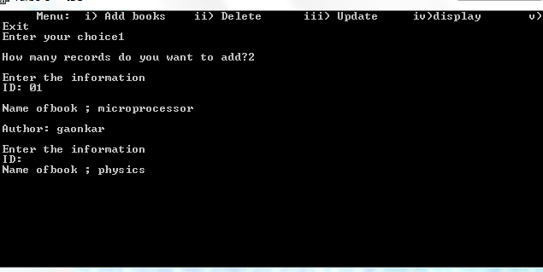

1. **Delete:**

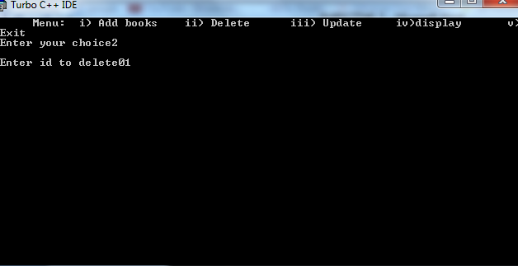

1. **Update:**

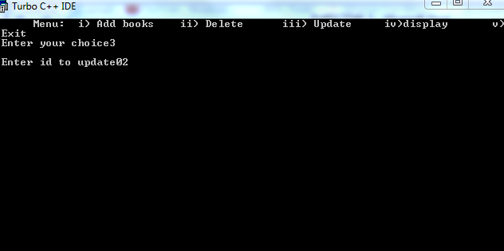

1. **Exit:**

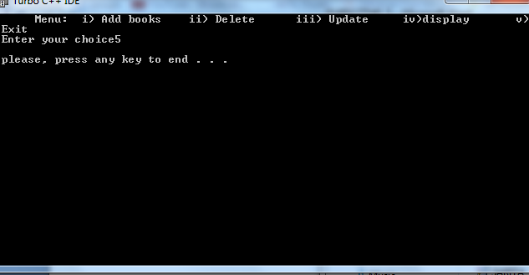

**CONCLUSION:** Hence, the program was successful, and “Library Management System” was implemented using function, structure and pointer including; insert, delete, display and update.